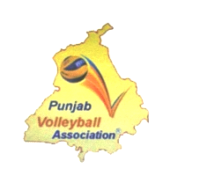 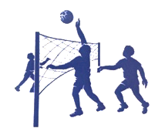 

PUNJAB VOLLEYBALL ASSOCIATION

Affiliated to Volleyball Federation of India & Punjab Olympic Association

President

**S. Kushaldeep Singh Dhillon**

M.L.A, Faridkot

Political Advisor

Chief Minister, Punjab

Kothi No: 1250, Sector 8-C,

Chandigarh

M- 9360900003

9915400039

[presidentdhillonpva@gmail.com](mailto:presidentdhillonpva@gmail.com)

[kikkidhillonmla@gmail.com](mailto:kikkidhillonmla@gmail.com)

General Secretary

**S. Sukhpal Singh Brar, P.P.S**

**Arujuna Awardee**

H.No: 185 New Defence Colony,

Old Phagwara Road , Deep Nagar,

Jalandhar Cantt.

M- 9646100043

7778000007

[secretarybrarpva@gmail.com](mailto:secretarybrarpva@gmail.com)

[dcptrafficldh@gmail.com](mailto:dcptrafficldh@gmail.com)